APPENDIX 10:
GAME DAY LOGISTICS

CLUB NAME
CLUB COVID OFFICER NAME AND CONTACT DETAILS
DATE OF GAME
MATCH PROMOTOR CONTACT
OTHER RELEVANT CONTACT DETAILS

GAME DAY INFORMATION:
VENUE ADDRESS (Google Link)
VENUE ENTRANCE
VENUE EXIT
WHERE SCREENING WILL TAKE PLACE? (Diagram may help)
GAME TIP TIME
COURT ACCESS TIME
VIDEO LINK (walk through of site)

OTHER INFORMATION:
IS THERE A ONE-WAY SYSTEM IN PLACE?
ARE CHANGING ROOMS AVAILABLE?
CAN YOU WARM UP ON COURT?
IS THERE A GAME BEFOREHAND?
IS THERE A FIRST AIDER ON SITE?
LOCATION OF DEFIB?

THIS FORM TO BE SENT TO THE OPPOSITION CONTACT AND ALL OFFICIALS FOR THE GAME.
SITE MAP – Picture or map as a minimum, additional video would be useful

COURT MAP – Please choose set-up most similar below

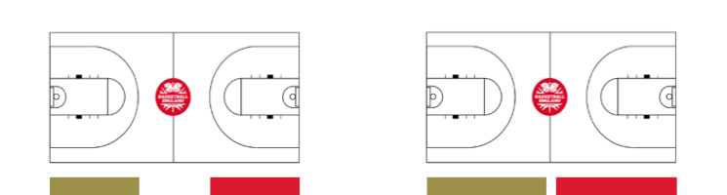
TABLE
TEAM B
TEAM B
TEAM A
TEAM A
TABLE

TRADITIONAL BENCHES OPPOSITE TABLE

TEAM B
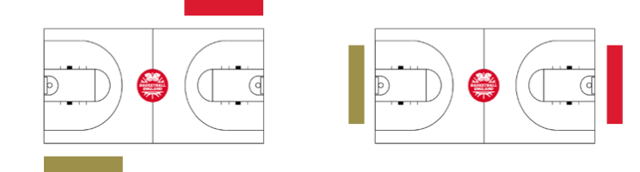
TEAM B
TEAM A
TEAM A
TABLE
TABLE

BENCHES ON OPPOSITE SIDES WRAP AROUND

THIS FORM TO BE SENT TO THE OPPOSITION CONTACT AND ALL OFFICIALS FOR THE GAME.

