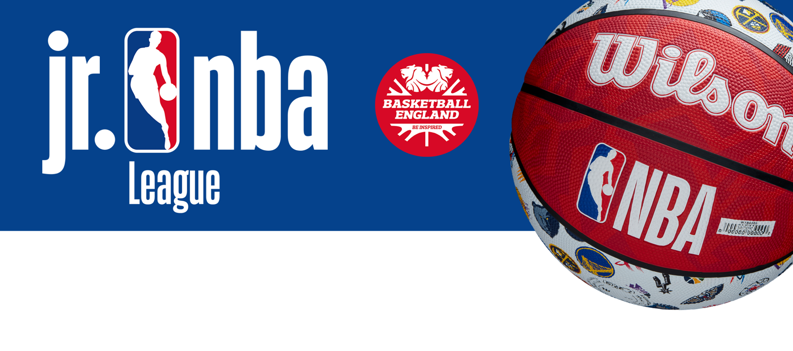

Please complete and modify as required
Dear Parent(s)/Guardians,

The Jr. NBA League is coming to your child’s school!

Boys and girls from our school will have the opportunity to play basketball in a Jr. NBA League organized by Basketball England in partnership with the NBA. The League will feature 30 school teams that will represent one of the 30 NBA teams throughout the season. The format will mirror the NBA including a team draft, regular season games, a single-elimination playoff and final to determine the Jr. NBA League Champion.

The school has been selected to represent the _____________________________
and we will have a new team kit to match theirs too!

To engage further with the league and stay connected we encourage you to download and register on OWQLO, the official app of the Jr. NBA Leagues. OWQLO has multiple functions including digital waivers that you must complete for your child to participate, scheduling, standings, and much more.
To find the waiver section in the OWQLO app please follow the steps below:

- Search for ‘OWQLO’ in your app store and register, be sure to verify your email.
- Press ‘Explore’
- Press on ‘Competitions’ on the top
- Press ‘Enroll’ on the Jr. NBA League England
- Press ‘Enroll a Minor’ and follow the steps from there

In addition, the app enables players, coaches, and families to access exclusively created content. Further information about the OWQLO app can be found at www.basketballengland.co.uk/leagues/jr-nba/.

If you need any further information, please don't hesitate to get in touch.

Best regards,

