Dear Colleague,

Basketball England have signed up to the **assignr** referee nominations programme for all of its Senior National League games (SNL).

If you have completed a registration with Basketball England, paid for your senior competitions and are eligible to referee in the SNL then you will shortly receive the email below from **assignr**.

This means that Basketball England has set up your profile in **assignr**.

Please follow the nominations instructions to set up your account so that you have access to your nominations.

|  |  |  |
| --- | --- | --- |
| Hi Name,  |  | | --- | | New Account Information | | An account with assignr.com has been created for you by your assignor.  assignr.com is a web-based service used to help referee and umpire assignors with game scheduling.  Please visit the following URL to begin:  [**https://basketballengland.assignr.com/password_resets/uRa6ScI72OiF9ZaNhp0T/edit**](https://basketballengland.assignr.com/password_resets/uRa6ScI72OiF9ZaNhp0T/edit?utm_source=outbound-email&i=444071)   * Your user name will be visible on this page. * In the box labeled **New Password**, type a new password for your account. * In the box labeled **Re-enter Password**, re-type the same password. * Click **Update my password and log me in**.   **If the above URL does not work:**   * You can visit the password reset page again to generate a new password reset request: [http://assignr.com/forgot](http://assignr.com/forgot?utm_source=outbound-email) * You can try copying and pasting the URL into your browser.   This URL will only work once. The link will be invalid once you have logged in to our site. It will also be invalid if a new password reset request is generated.  If you've tried these steps and still can't get in, contact us at [support@assignr.com](mailto:support@assignr.com). | |
| Thanks for using assignr.com,  Basketball England  |  |  | | --- | --- | | [Twitter](http://twitter.com/assignr) | [Facebook](http://www.facebook.com/pages/assignrcom/150881398265666) |  Keep up with the latest assignr news [on our blog](http://blog.assignr.com?utm_source=outbound-email)  Share your [questions and feedback](http://assignr.zendesk.com/forums?utm_source=outbound-email)  View [assignr system status](http://status.assignr.com)  [Reset your Password](http://assignr.com/forgot) |

When you click on the link from the welcome email you will be sent to the below page.

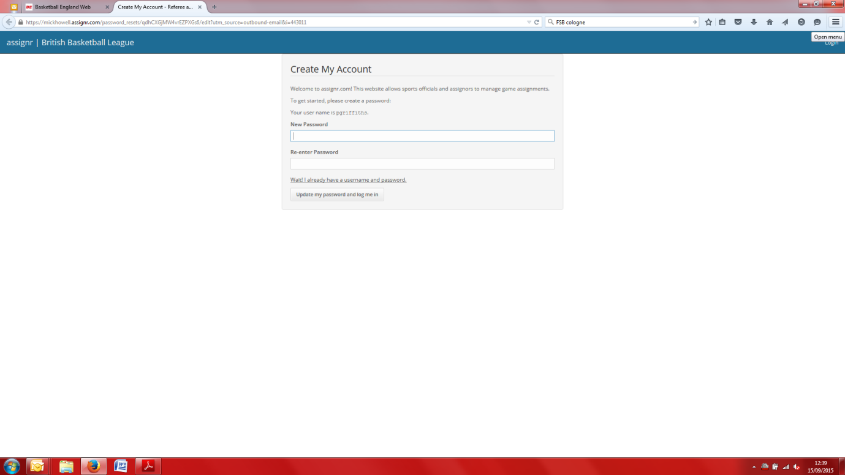

Here you will set up a password to access your account.

You will then be asked to read and agree to the terms and condition.

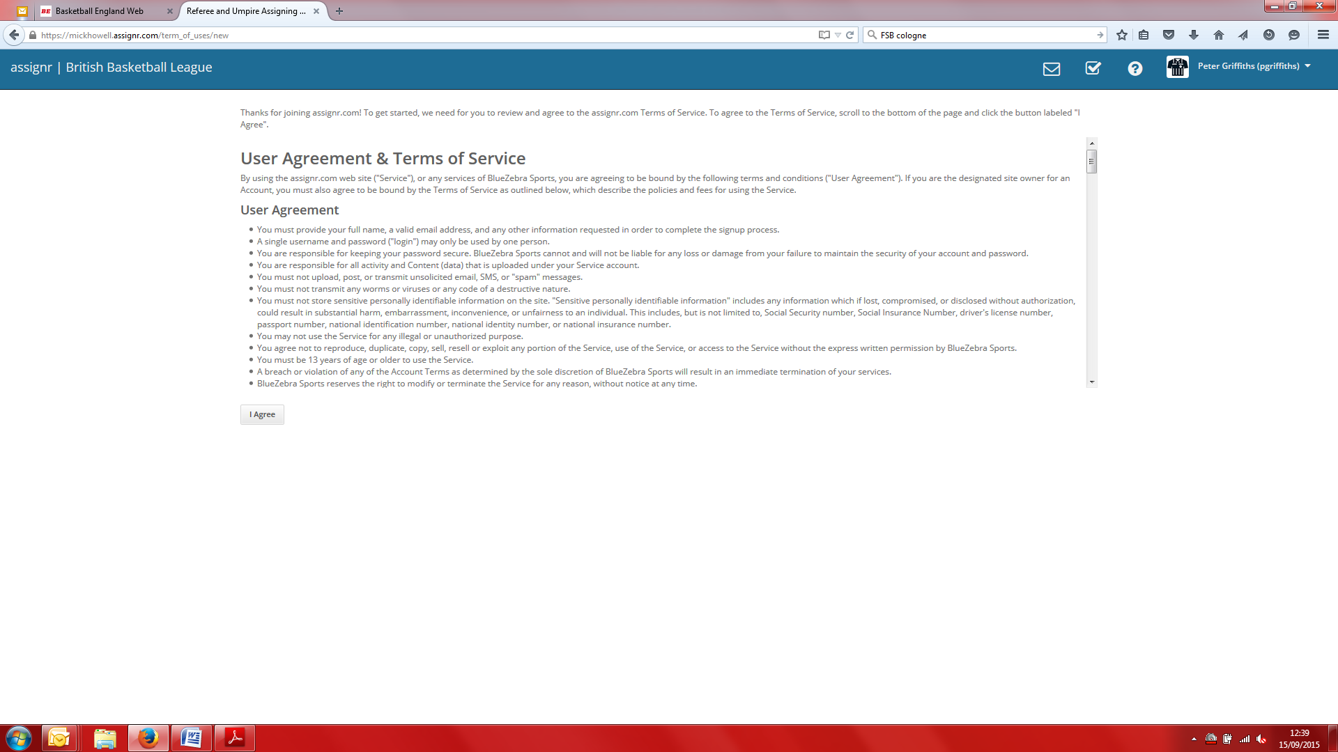

You will then be sent to the home page.

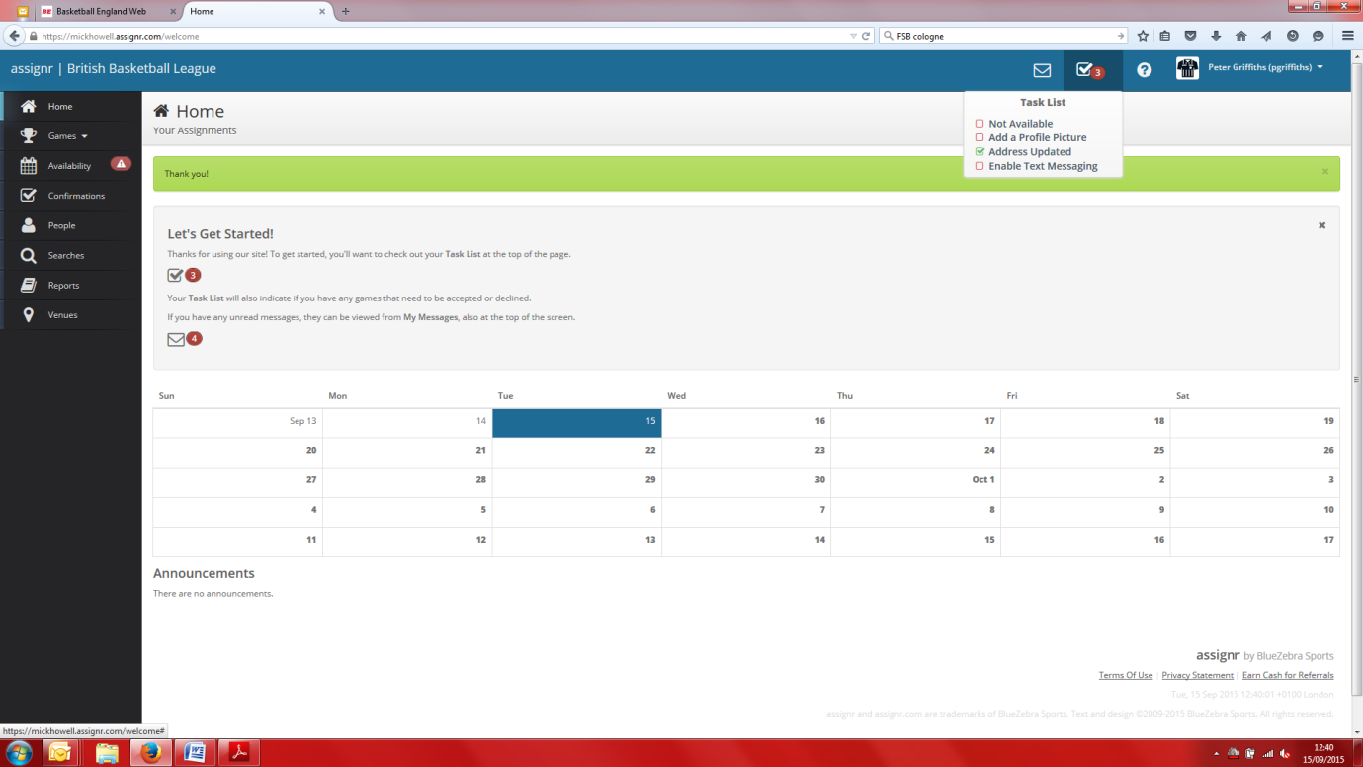

From the home page you can complete a number of actions:

* Update your availability (assignr has defaulted you as unavailable for all days so you will have to make yourself available for days you wish to receive games)
* View your games nominations
* Accept or decline a game you have been assigned to

Availability page

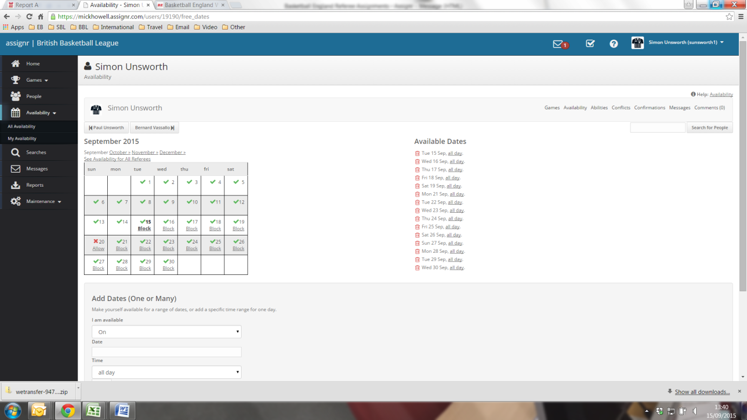

Games & Nominations Page

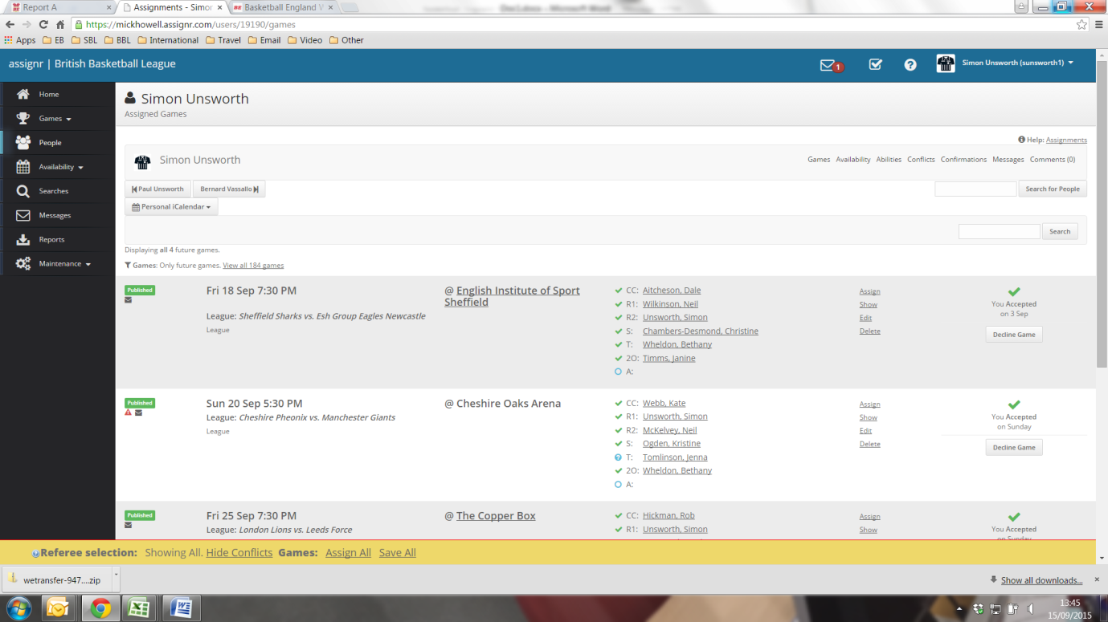

You will receive a notification from assignr for new nominations or details changes for of your game current assignments.

* Venue, date or tip change
* Game cancellation
* Co-official change

If you have any questions about using the system please contact Simon Unsworth directly on [simon.unsworth@basketballengland.co.uk](mailto:simon.unsworth@basketballengland.co.uk)